**LAB 9**

# Task 1: Two 4-bit number comparator.

1. Write truth table

|  |  |  |  |  |  |  |
| --- | --- | --- | --- | --- | --- | --- |
| **A1** | **A0** | **B1** | **B0** | **L** | **E** | **G** |
| 0 | 0 | 0 | 0 | 0 | 1 | 0 |
| 0 | 0 | 0 | 1 | 1 | 0 | 0 |
| 0 | 0 | 1 | 0 | 1 | 0 | 0 |
| 0 | 0 | 1 | 1 | 1 | 0 | 0 |
| 0 | 1 | 0 | 0 | 0 | 0 | 1 |
| 0 | 1 | 0 | 1 | 0 | 1 | 0 |
| 0 | 1 | 1 | 0 | 1 | 0 | 0 |
| 0 | 1 | 1 | 1 | 1 | 0 | 0 |
| 1 | 0 | 0 | 0 | 0 | 0 | 1 |
| 1 | 0 | 0 | 1 | 0 | 0 | 1 |
| 1 | 0 | 1 | 0 | 0 | 1 | 0 |
| 1 | 0 | 1 | 1 | 1 | 0 | 0 |
| 1 | 1 | 0 | 0 | 0 | 0 | 1 |
| 1 | 1 | 0 | 1 | 0 | 0 | 1 |
| 1 | 1 | 1 | 0 | 0 | 0 | 1 |
| 1 | 1 | 1 | 1 | 0 | 1 | 0 |

1. Kmaps

For L

|  |  |  |  |  |
| --- | --- | --- | --- | --- |
| A1A0/B1B0 | 00 | 01 | 10 | 11 |
| 00 |  | 1 | 1 | 1 |
| 01 |  |  | 1 | 1 |
| 10 |  |  |  |  |
| 11 |  |  | 1 |  |

L=A1’B1+A1’A0’B0+A0’B1B0

For E

|  |  |  |  |  |
| --- | --- | --- | --- | --- |
| A1A0/B1B0 | 00 | 01 | 10 | 11 |
| 00 | 1 |  |  |  |
| 01 |  | 1 |  |  |
| 10 |  |  | 1 |  |
| 11 |  |  |  | 1 |

E=(A1 XNOR B1)(A0 XNOR B0)

For G

|  |  |  |  |  |
| --- | --- | --- | --- | --- |
| A1A0/B1B0 | 00 | 01 | 10 | 11 |
| 00 |  |  |  |  |
| 01 | 1 |  |  |  |
| 10 | 1 | 1 |  | 1 |
| 11 | 1 | 1 |  |  |

G=A1B1’+A0B1’B0’+A1A0B0’

1. Fill the following table in order to determine the gate cost for the implementation of binary comparator using SOP expressions found in part (b)

|  |  |  |  |
| --- | --- | --- | --- |
| IC type | Required No. of Gates | Gates per IC | Required No. of ICs |
| 74LS08 | 11 | 4 | 3 |
| 74LS32 | 4 | 4 | 1 |
| 74LS04 | 4 | 6 | 1 |
| 74L266 | 2 | 4 | 1 |
| Total no. of ICs | | | 6 |

# Task 2: 4-bit full adder and subtractor.

Adder:

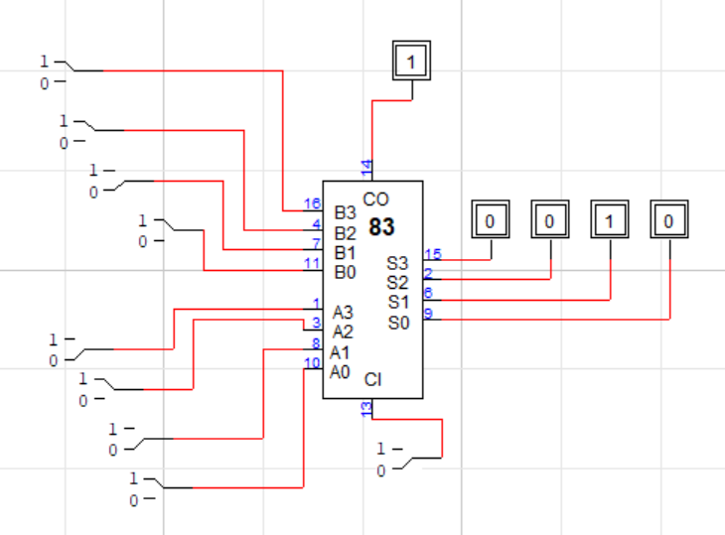

Subtractor:

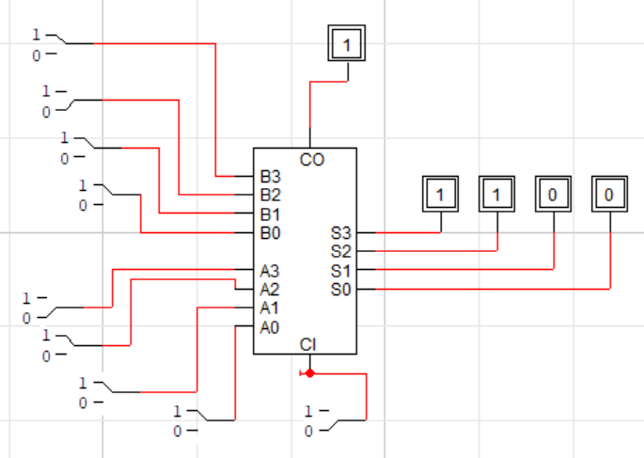

# Task 3: 4-bit Multiplier made using the 4-bit adder

